Safe Kids Car Seat Check Up Event Evaluation

Please submit 14 days after an event – Before mailing, please double check event forms for accuracy.

(Please complete electronically and email to Jason.kerkman@nebraska.gov)

Submitted by: Click & enter name | Date: Click & select date from calendar
Sponsor Organization: Click & enter name of event organizer or sponsor.
Event Location: Click & enter name & city event held | Event date: Click & select a date from calendar
Senior Checker(s): Click here to enter name.
Was the event registered with Safe Kids Nebraska? Yes No
Was the event registered with a local Safe Kids Program? Yes No

- Use the up or down arrow keys to move between fields. When a field is highlighted, press F1 for instructions. A pop up box will provide more information about how to enter data.

Event Attendance Information

Number of families reached: 0
Number of parents/caregivers reached: 0
Number of children reached: 0

Total Number of Event Attendees: 0

Staffing

Event duration in hours: 0.00
Number of volunteers (non-CPST) 0
Number of CPST/CPSTI: 0
Total number of volunteers supporting the overall event: 0
Number of volunteer hour (non-CPST): 0.00
Number of CPST/CPSTI hours: 0.00
Total number of volunteer hours (CPST’s and all volunteers): 0.00

Car Seat Installation Information

Number of installed car/booster seats checked: 0
Number of car seat registration cards completed and mailed: 0
Number of car/booster seats arrived uninstalled: 0
Number of checklist forms completed: 0
Number of installed car/boosters seats checked found incorrectly used: 0
Number of car seats recalled: 0
Number of children of CSS size/age who arrived without CSS: 0
Event Misuse Rate:

Car Seat Distribution Details

Number of Infant Only: 0
Number of Convertible: 0
Number of FF Harnessed (FF only seats): 0
Number of All-in-one: 0
Number of Backless Boosters: 0
Number of High Back Boosters: 0

Total Number of Car Seats/Booster Seats Distributed: 0

Additional Information

Number of seats ordered with grant: 0
Number of grant seats distributed: 0

Please explain how remaining seats will be used/distributed.

Provide an overall assessment of the event including successes, challenges and outreach efforts, if any.

Media

Number of TV stories: 0

Number of radio stories: 0

Live remote TV coverage:
Yes No

Number of print media stories: 0

Social Media Presence:
Yes No
Type of Social Media: Facebook Twitter Instagram Other

Live remote radio coverage:
Yes No

Number of tip sheets distributed in English: 0

Number of tip sheets distributed in other languages: 0

Did you introduce the Safe Kid’s online Ultimate Car Seat Guide to the attendees? Yes No
If yes, how many? 0

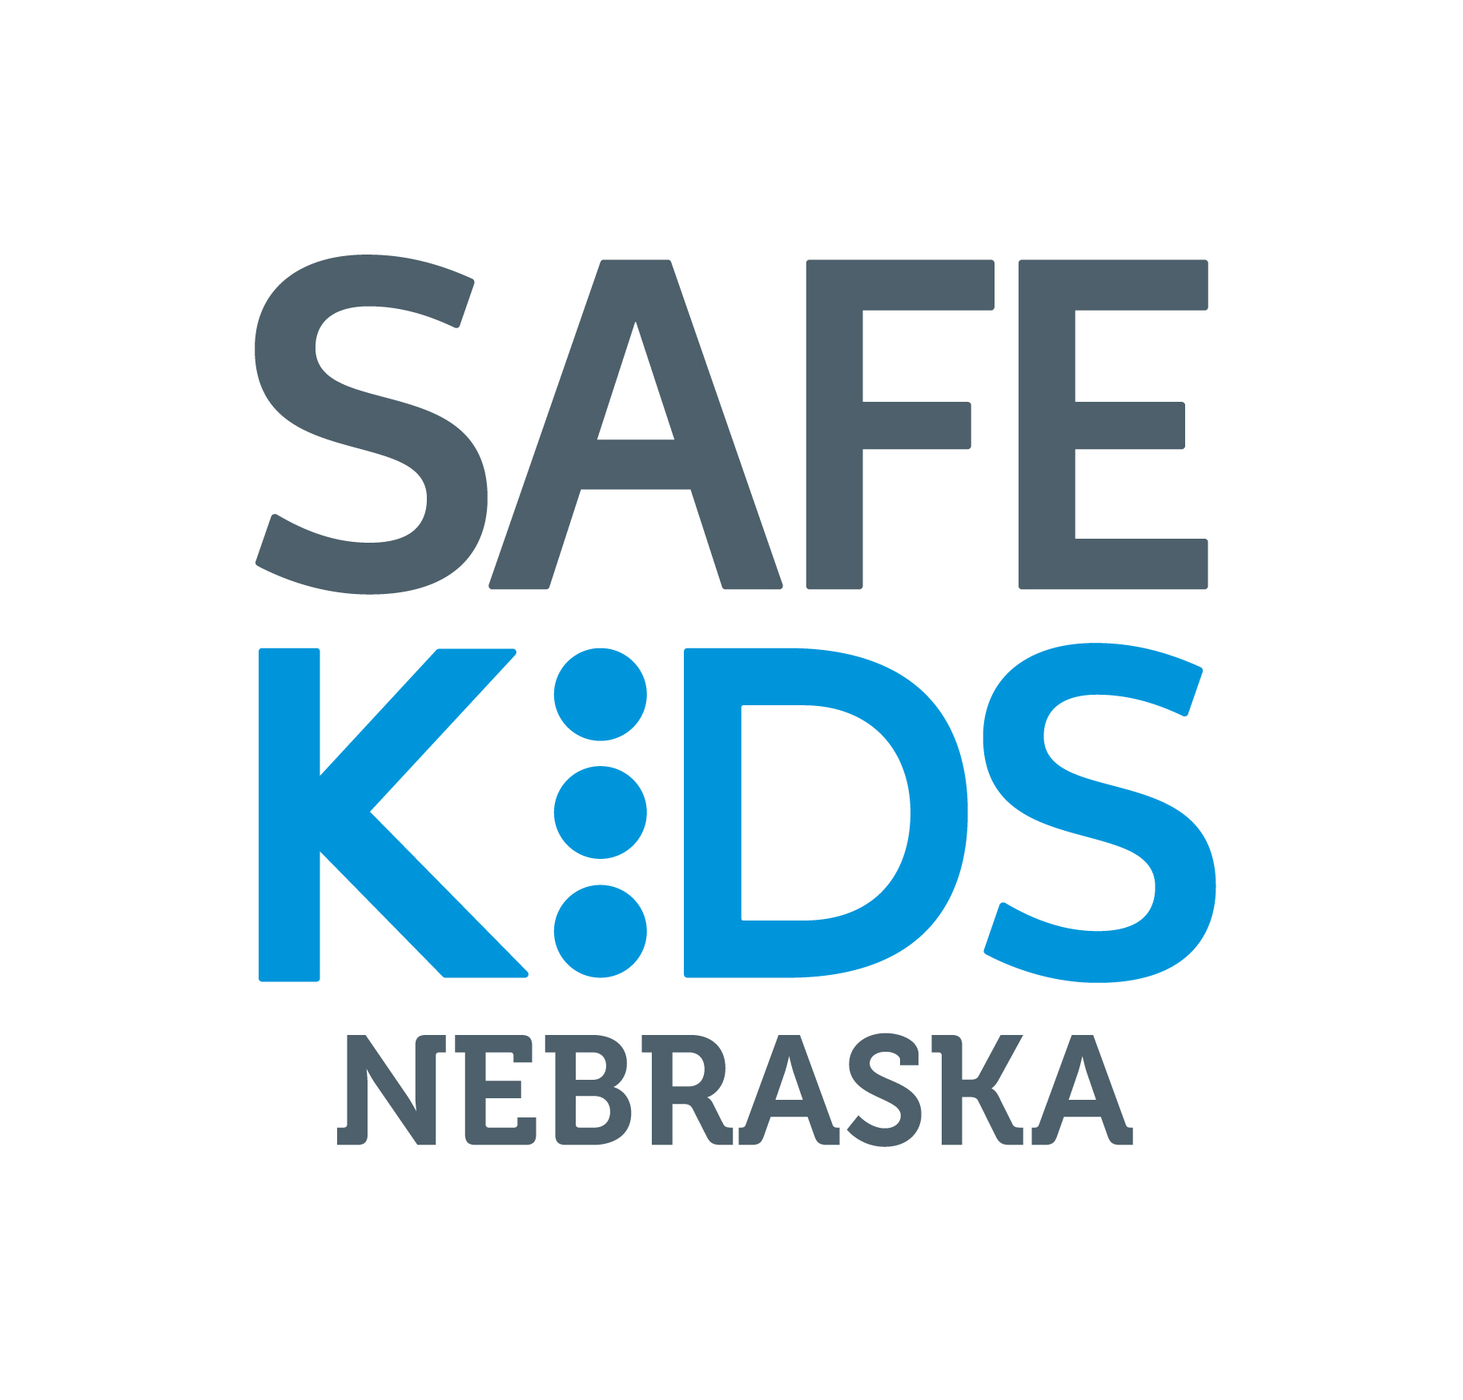
Jason Kerkman- Injury Prevention Program/Safe Kids Coordinator-
Nebraska Department of Health & Human Services
301 Centennial Mall South, PO Box 95026- Lincoln, NE-68509
Jason.kerkman@nebraska.gov office: 402-471-8749 or fax:402-471-6446

